**Chapter 2: Chrome Console**

In JavaScript, the console is an object which provides access to the browser debugging console. The console object is accessed with **window.console** or just **console**.

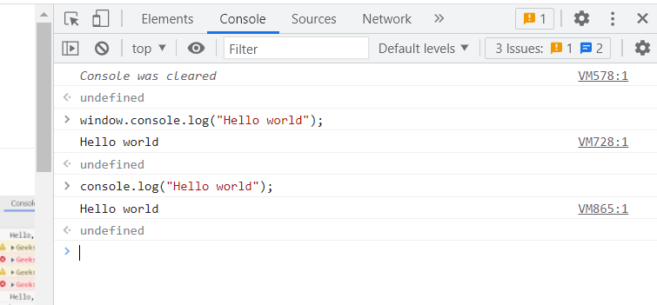

The console object has many methods like:

1. **console.log();**

This method allows to write a message to the console

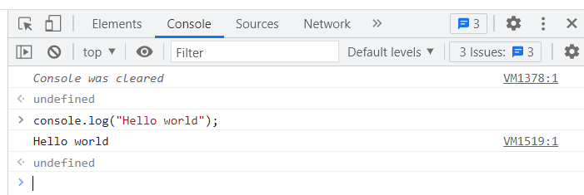

1. **console.clear();**

This method allows to clear the console.

1. **console.assert();**

This method writes a message to the console if an expression evaluates to false.

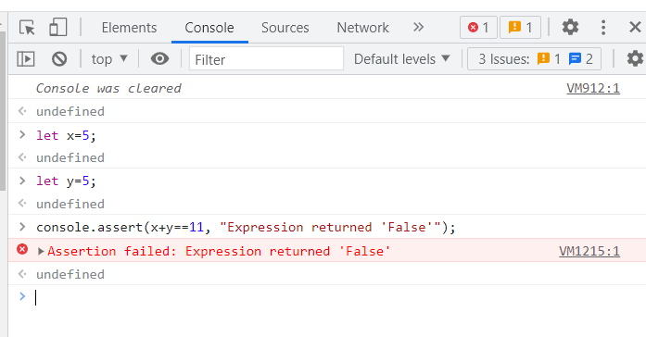

1. **console.dir();**

This method allows to write the message directly on the console.

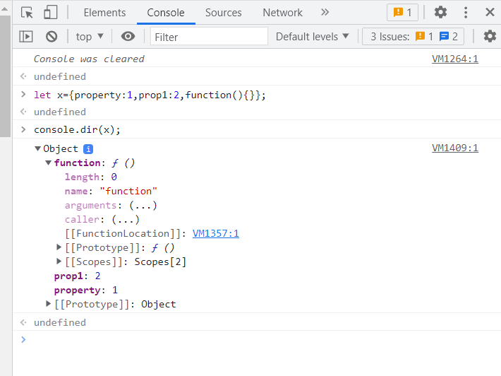

1. **console.error();**

This method displays an error message.

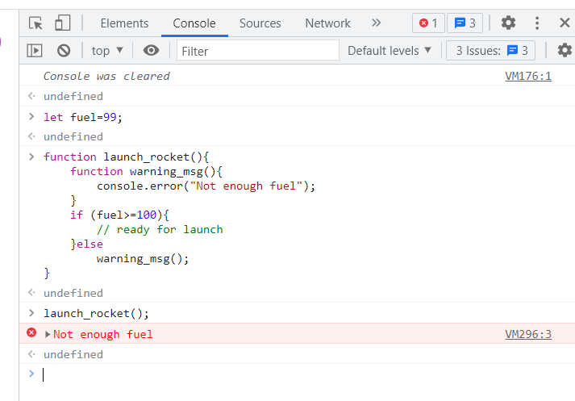

1. **console.group();**

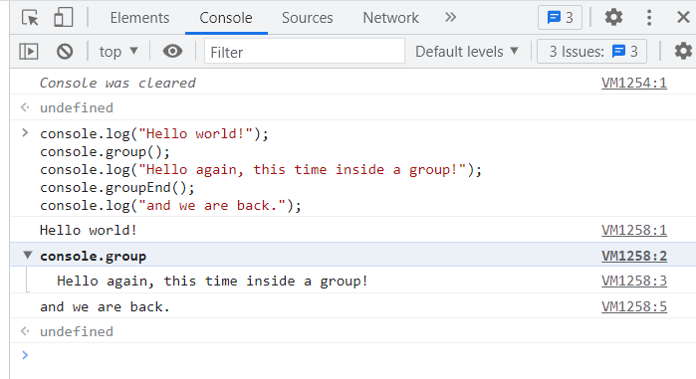

1. **console.count();**

The count() method counts the number of times console.count() is called.

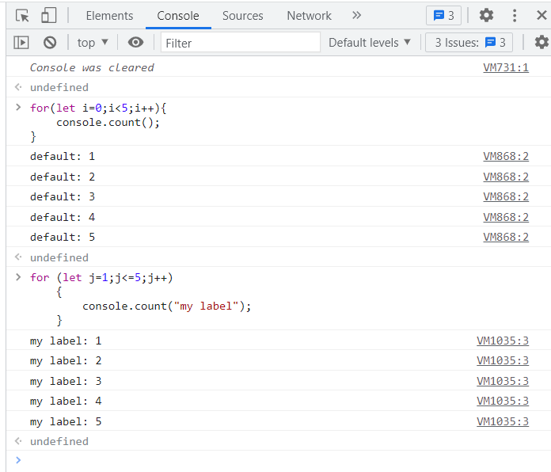

1. **console.time(); and console.timeEnd();**

console.time(); - The timer is started when this method is called.

console.timeEnd(); - The timer is stopped when this method is called.

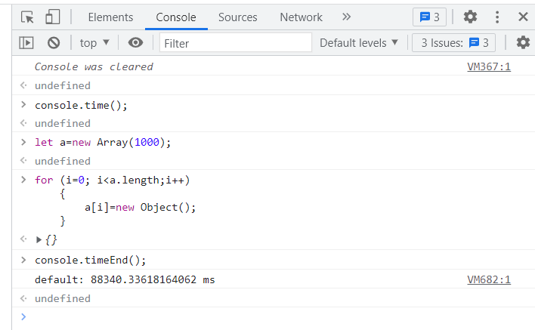

1. **console.table();**

